Daybook Posting

Contents

Overview 1
Details 3
PrePostInput (PostInpU.pas) 3
Prepare and display the filter dialog 3
Prepare the list of document types 3
Add to the thread queue 4
Prepare and display the Job Costing options dialog 4
Add the Job Costing task to the thread queue 4
TEntPost.Control_Posting (PostingU.pas) 5
Prepare a list of document types 5
Check any hook points 5
Process Auto transactions 5
Process batch transactions 5
Process transactions 5
Auto-Transactions 6
TEntPost.Post_ItAuto (PostingU.pas) 7
Prepare job-costing 7
Prepare notification hook 7
Adjust list of document types 7
Prepare print forms 7
Locate first Auto record 7
Check for on-hold or suspended 7
Save record position 7
Read and adjust currency rates 7
Determine period/year or date 8
Calculate the due date 8
Store operator name 8
Determine VAT date 8
Set document allocation status 8
Assign next document number 8
Assign next folio number 9
Generate transaction lines 9
Save transaction 10
Update balance 10
Print report 10
Call hook point 10
Update or delete auto transaction 10
Locate next auto record 10
Print reports 10
tdPostExLocal.LUpdateBal (ExBtTh1U.pas) 11
Locate the customer/supplier record 11
Prepare the credit/debit amounts 11
Update the balance history 11
Update ‘last edited’ flag 11
tdPostExLocal.LPost_To_Hist (ExBtTh1U.pas) 12
Locate history record 12
Calculate balances 12
Batch Transactions 13
TEntPost.Post_ItBatch (PostingU.pas) 14
Prepare job-costing 14
Locate first batch record 14
Increment PostingCount 14
Update LastFolio 14
Check transaction 14
Lock record 14
Post details 14
Save record 14
Update customer/supplier balance 14
Next record 14
TEntPost.Post_BatchDetails (PostingU.pas) 15
Locate batch transactions 15
Lock record 15
Determine VAT Date 15
Set document allocation status 15
Save record 15
Update customer/supplier balance 15
Update Job Costing 15
Find next record 16
TPostJob.LUpdate_JobAct (JobPostU.pas) 17
Locate record 17
Check transaction line 17
Assign/calculate values 17
Save record 17
TEntPost.Post_AdjDetails (PostingU.pas) 18
Check Stock Valuation flag 18
Create Nominal Transfer record 18
Locate transaction lines 18
Update history 18
Substitute stock parameters 18
Get nominal codes 18
Call hook point 18
Add stock valuation lines 18
Add Job Costing uplift 19
Finalise transaction line 19
Finalise transaction 19
Main Posting 20
TEntPost.Post_It (PostingU.pas) 22
Initialise 22
Check transaction 22
Prepare transaction for editing 22
Post transaction lines 22
Post control code lines 22
Finalise transaction 22
Post Nominal Codes 22
Print summary report 23
TEntPost.Post_Details (PostingU.pas) 24
Locate first transaction line 24
Calculate totals 24
Update balance history 24
Process pay-in lines 24
Process job costing 24
Finalise transaction line 24
Code sample 25
From PostingU.pas 25

Overview
Daybook Posting is launched via the Daybook Post button on the Daybook dialog.

This then displays a list of document types, to allow the user to include/exclude the document types for the posting run.

The Daybook Post task is added to the thread list, and the Process method of the TEntPost object (which handles the main posting) will be called by the thread controller.

The posting routine starts with Post_ItAuto, which adds transaction records for all the relevant Auto transactions.

It then calls Post_ItBatch, which locates all the relevant batch transactions, and creates transaction records for all the transactions in the batch. ???

The Post_It routine is then called, which actually posts the transactions, then adds a print task to the thread list, to print the Daybook Post report.

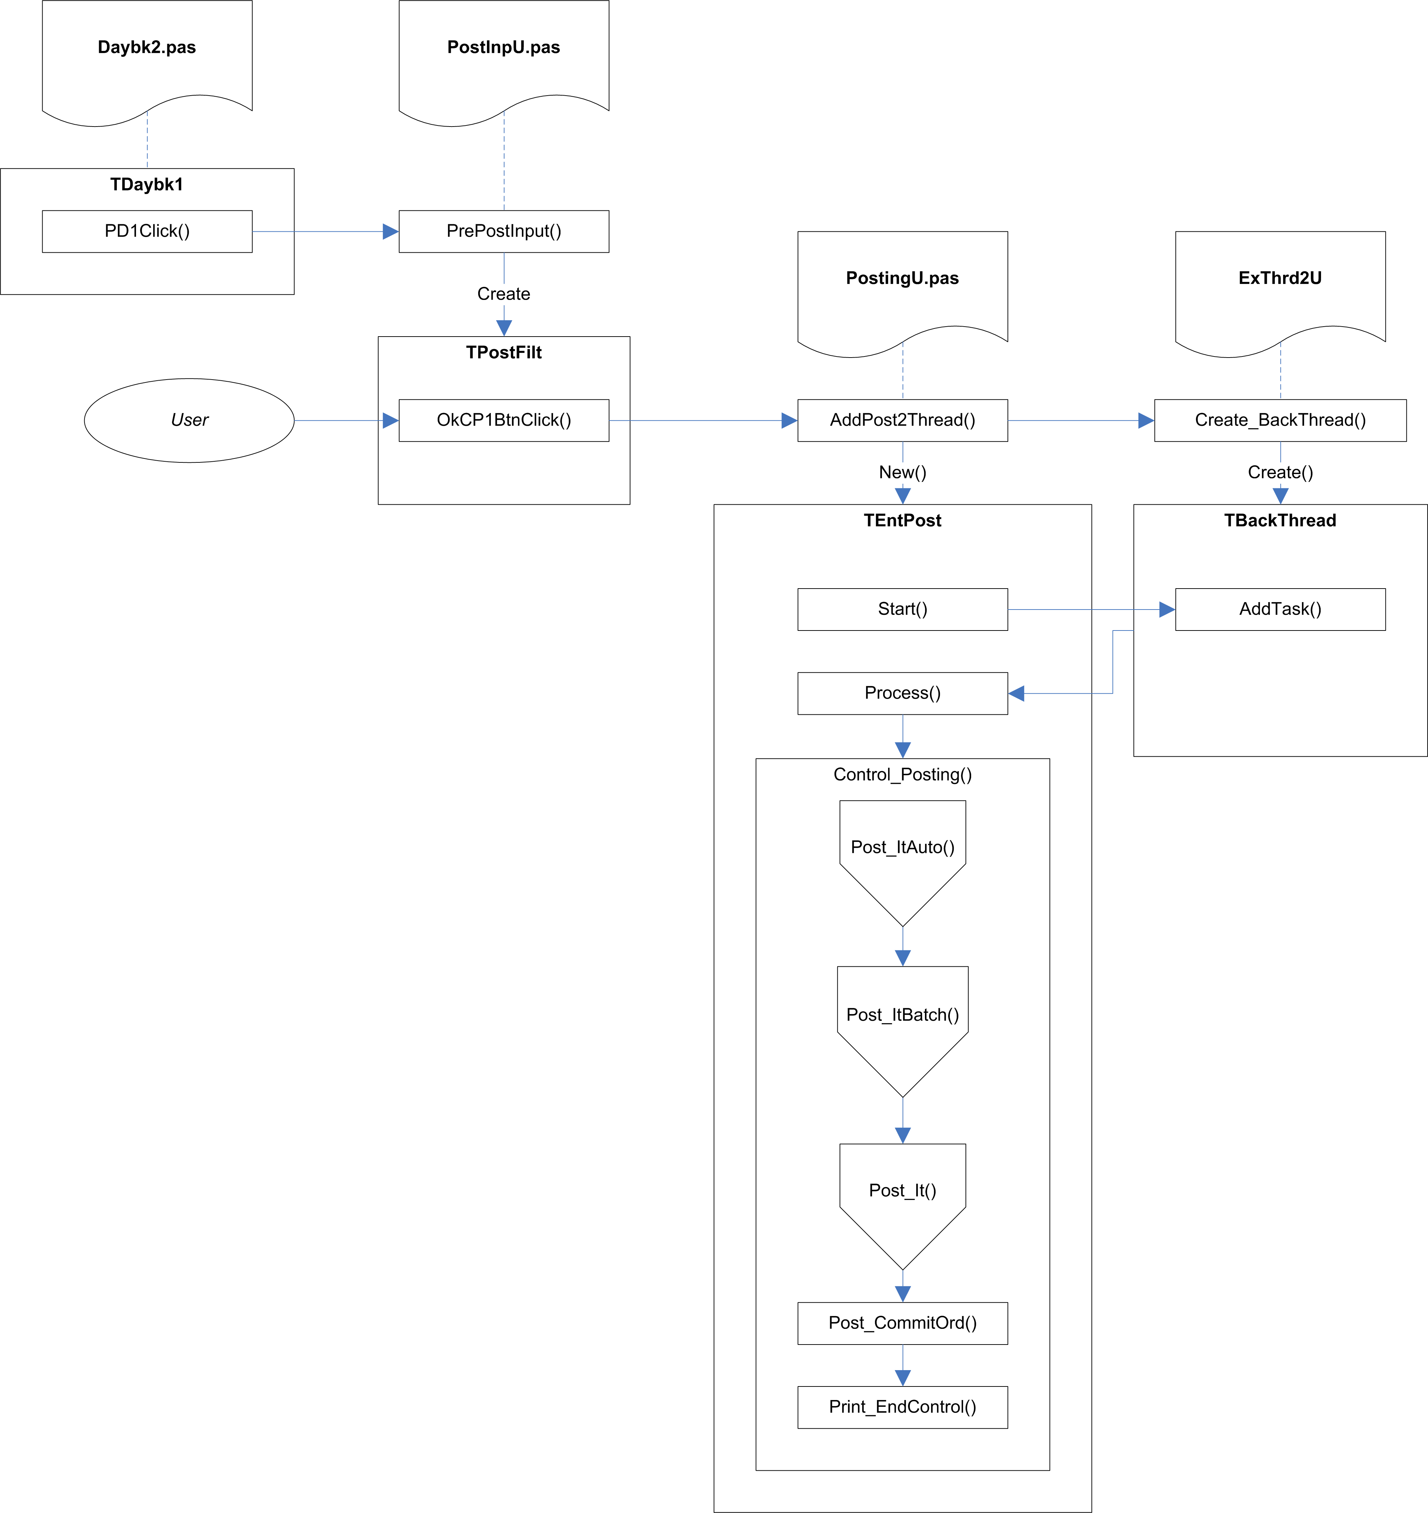

Fig.1 Overview

Details
The routine starts when the user clicks the Daybook Post button on the DayBook dialog. This calls the PrePostInput procedure in PostInpU.pas.

PrePostInput (PostInpU.pas)

Parameter | Comments
AOwner: TComponent | The Daybook dialog passes itself as this parameter.
PMode: Byte | This uses the SetPostMode function in PostingU.pas, which takes a document type, and determines the posting mode from it:  1=Sales  2=Purchase  3=Nominal  4=Stock Adjustment.  If the Daybook dialog is currently displaying Auto Transactions, 20 is added to the mode.
PAsk: Boolean | This is passed as True.
PParam: TPrintParamPtr | This is passed as nil, and hence is not used.

Prepare and display the filter dialog
The PMode value is copied to a file-wide variable, GPMode, so that it is available to the filter dialog (the filter dialog copies the value to its own PostMode property).

The filter dialog, TPostFilt, is created and automatically displayed, to allow the user to select which document types are to be processed. By default, all the document types relevant to the posting mode are selected.

If the PostMode property is greater than 10, the AutoOn property is set to True, and the PostMode property is decremented by 20 (this should return it to the basic mode value of 1, 2, 3, or 4).

The Ask property of the PostFilt dialog is copied from the PAsk parameter (and hence is set to True).

A CRepParam record structure is created and initialised (all fields are blanked). This record is used to pass information to the posting routines.

The ‘Separate Posting Control Entries’ checkbox is defaulted to the value stored in SepRunPost in System Settings (Syss). Checking or unchecking this checkbox will automatically update the System Settings value as well.

Prepare the list of document types
When the user clicks the Ok button on the TPostFilt dialog, a set of selected document types is created in the IncDocSet set (a set of DocTypes, defined in X:\SBSLib\Win\ExCommon\VarComnU.pas).

[A matching set of excluded document types is created in ExcDocSet, but this appears not to be used.]

If a JRN document type is found in the set, it is removed, and the PostJCDBk field of the CRepParam record structure is set to True, to indicate that Job Costing is to be included in the posting run. ???

The set of selected document types, IncDocSet, is copied to the IncDocFilt field of CRepParam.

If the AutoOn property is True, the PostMode field of the CRepParam record structure is incremented by 20, to indicate that Auto transactions should be included.

[The CRepParam.PostMode field does not seem to have been previously set to a valid Post Mode.]

Add to the thread queue
AddPost2Thread, in PostingU.pas, is called to create a TEntPost object for handling the posting, and to add this task to the thread queue.

Prepare and display the Job Costing options dialog
If Job Costing is enabled (the PostJCDBk field of CRepParam is set to True), the Got_JCTransToPost function in JPstInpU.pas is called. This searches the Job Details table for any records with a Run Number of zero.

If any records are found, the JPrePostInput procedure in JPstInpU.pas is called, which creates and displays the TJPostFilt dialog to allow the user to specify the Job Costing options.

Add the Job Costing task to the thread queue
When the user clicks Ok on the TJPostFilt dialog, the JPostCtrl record structure is updated with the selected options, and AddJobPost2Thread, in JobPostU.pas, is called to add the Job Costing task to the thread.

The thread queue calls the Process method on TEntPost and TPostJob to carry out the actual postings.

TEntPost.Process passes control on to the Control_Posting method, passing the current posting mode.

TEntPost.Control_Posting (PostingU.pas)

Parameter | Comments
Mode: Byte | This will be TEntPost.PostMode + 20 if Auto transactions are included

Prepare a list of document types
If Mode is greater than 10, the AutoOn local variable is set to True, and 20 is subtracted from the Mode value.

GetPostMode is called to fill the PSet local variable (a set of DocTypes) with the relevant document types for the mode.

Check any hook points
The Cost of Sales G/L Code hook point, Adjustment G/L code hook point, and Line Date Protection hook point are checked to see if they are enabled. The last one acts simply as a flag to decide whether or not line dates should be synchronised with header dates. The first two will result in the appropriate hook points being called when they are reached.

Process Auto transactions
If AutoOn is set to True, the Post_ItAuto method is called, with the NormalPost parameter set to True. This will create transactions for all the active auto transactions for the selected document types and date or period.

The Daybook Process ends at this point if AutoOn is True – the transactions are created from the auto-transactions, but are not actually processed.

If AutoOn is set to False, the Post_ItAuto method is called, with the NormalPost parameter set to False. This will then process auto transactions which have AutoPost set to True, for the selected document types and date or period.

Note: If the Daybook Process is called while the Auto Transactions tab is current, AutoOn will be true, and all active auto transactions will be processed. If any other tab is current, AutoOn will be false, and only those transactions with ‘AutoPost’ set to True will be processed (this flag is set by the ‘Auto create when posting daybook’ checkbox on the Auto Settings dialog).

Process batch transactions
The Post_ItBatch method is called, which sets the allocation status and run number for all the transactions in the batch.

Process transactions
The Post_It method is called to do the main posting of transactions.

Auto-Transactions

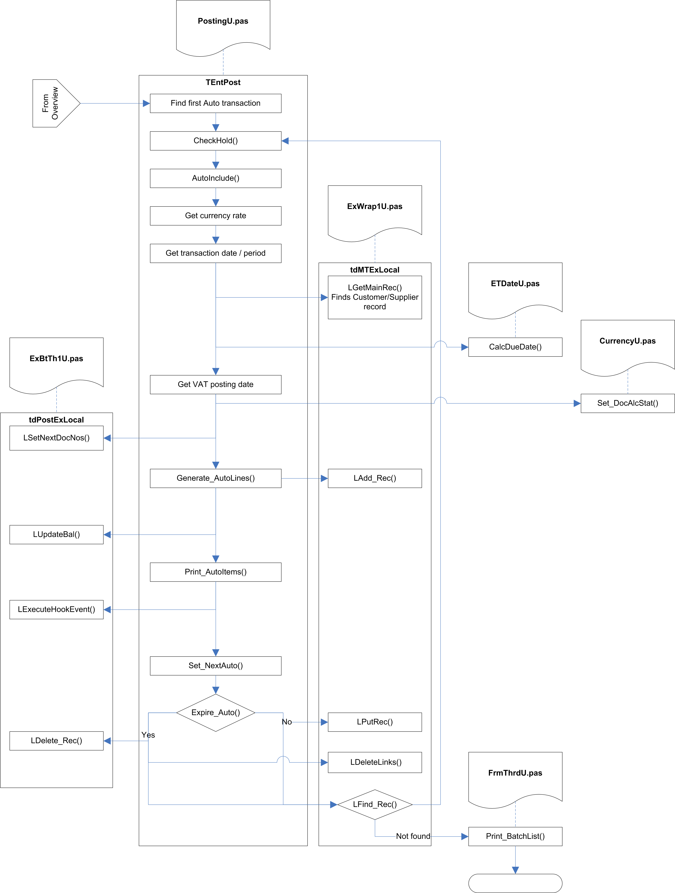

Fig.2 Post_ItAuto

TEntPost.Post_ItAuto (PostingU.pas)

Parameter | Comments
PostSet: DocSetType | Set of DocTypes
PrintToQueue: Boolean | Always False when called from Control_Posting
ItemsOnQ: Boolean | Always False when called from Control_Posting
Curr_Pno: Byte | Always 0 when called from Control_Posting
NormalPost: Boolean

Prepare job-costing
If the JobCostOn (VarConst.pas) global flag is set to True, a PostJobObj object is created. Subsequently, the MTExLocal record structure of TEntPost is copied to the MTExLocal field in the PostJobObj.

Prepare notification hook
The HookNotify flag is set to True if the Notify Auto SIN hook point is enabled.

Adjust list of document types
A copy is taken of the PostSet set of document types. If SIN transactions are included, the SQU document type is added both to this copy and to the IncDocFilt record in PostRepCtrl. If PIN transactions are included, the PQU document type is added both to this copy and to the IncDocFilt record in PostRepCtrl.

Prepare print forms
An instance of TPFormList is created, in a ThisFList local variable. This maintains a list of reports to be printed.

Locate first Auto record
It then searches for the first Auto transaction. It does this by looking for the first record in Document.Dat which has an Auto-Run number (-2), and a folio number greater than
-2147483647 (FirstAddrD constant in X:\SBSLib\Win32\Btrvu2.pas).

Check for on-hold or suspended
The CheckHold function is called to check if the current transaction record is on hold or suspended. This checks the HoldFlg pseudo-bitfield, to see if contains the HoldSuspend value (128). If so, the transaction is the point at which the posting run must be stopped, and the default set of document types is subtracted from the current set of document types.

[The HoldSuspend check is probably not relevant for Auto transactions, and the subtraction of document types at this point will end up with a set that potentially contains only SQU or PQU – this is probably wrong, but if Auto transactions cannot be suspended, then this situation will never actually occur.]

CheckHold then checks if the HoldFld field contains any of the On Hold values, and returns True if it does.

Save record position
The record position is now saved. This is because the following sections will be creating a new transaction record, based on the information stored in the Auto record. After this record is added to the file, the record position will be restored to take us back to the Auto record that was being processed.

Read and adjust currency rates
If the document type is not a nominal posting (NMT/NOM), the currency rates are read from the System Currency Setup (SyssCurr), along with the triangulation rates for Euro conversion. If the document type is not one of the direct payment types (SRF,SRI,PRF,PPI, read from the DirectSet constant in X:\SBSLib\Win\ExCommon\VarComnU.pas), then the Company Rate is set to zero.

Determine period/year or date
The AutoIncBy indicator is checked to determine whether we need to calculate the Transaction Date or the Period, and either converts the date to a period/year, or converts a period/year to a date. This triggers a hook point to allow the returned period/year or date to be amended.

Calculate the due date
The customer/supplier record is located and read. The due date is calculated based on the transaction date and the customer/supplier’s payment terms.

Payment terms usually hold the number of days credit for the customer/supplier. There is a special system in place for payment on a specific day of the month. This involves using a payment terms value greater than 500, in which case the correct value is calculated on the following basis:

900 + n = nth day of the following month.
800 + n = nth day of the second month following.
700 + n = nth day of the third month following.
600 + n = nth day of the fourth month following.
500 + n = nth day of the fifth month following.

Store operator name
The current log-in name is stored in the OpName field of the Document record.

Determine VAT date
If the VAT Scheme indicator in the System Setup indicates that VAT on Cash Accounting is in use (that is, if SyssVAT.VATRates.VATScheme holds ‘C’), and if the current document is one of the direct payment types (SRF,SRI,PRF,PPI), then the VAT date is calculated.

Currently, this is simply read from the System Setup (SyssVAT.VATRates.CurrPeriod), but in future it will be calculated using the CalcVATDate function in SysU1.pas – this function calculates and returns the VAT date based on the supplied transaction date. If the transaction date indicates a date in advance of the current period, it returns the last day of the month that the transaction date actually falls in.

The UntilDate is set to today, to indicate that this transaction was fully allocated at this date.

Set document allocation status
The Set_DocAlcStat procedure in CurrencyU.pas is called to the set the allocation status.

If the document is in the Allocation set (PIN,PCR,PJI,PJC,PPY,SIN,SCR,SJI,SJC,SRC), the AllocStat field is set to ‘S’ for supplier or ‘C’ for customer, and #254 is stored in the UntilDate field. For other document types the AllocStat field is set to #0, and the UntilDate field is left unchanged.

If the System Setup authorisation mode holds ‘A’, and the HoldFlg value does not indicate that the record in on hold, the HoldFlg value is set to HoldP – Authorise Payment.

Assign next document number
This calls the tdPostExLocal.LSetNextDocNos method in ExBtTh1U.pas to get the next available document reference for the current document type.

The tdPostExLocal.LGetNextCount method is called to locate and update the document number in the Increment table. The tdPostExLocal.FFullDocNum method builds a full reference based on this number.

The reference number is created using the following recipe:

- Get the next available document number (using LGetNextCount).
- Convert this to a string.
- If the string is more than 6 characters long:
    - Extract the first two characters of the string.
    - Convert them to a number.
    - If this number is less than 33 and greater than 10:
      - Subtract 10.
      - Use the result as an index into an array of characters (A to Z, excluding I, O, and S).
      - Store the indexed character as the suffix.
      - Copy the next 5 characters from the string, as the trailing string.
      - Convert them to a number.
      - Convert the result back into the trailing string.
    - Concatenate the document type string, the suffix, and the trailing string.
    - Return the result as the new reference.

[ If step 3.ii results in a number less than 10 or greater than 33, the returned reference will be in the normal format, but will be too long to be valid. ]

[Steps 5 and 6 seem redundant.]

[A ‘next count’ number greater than 10 000 000 will return the wrong reference (as step 4 will ignore characters beyond the seventh character in the string).]

The resulting reference is searched for in Document, to make sure it does not already exist. If it does exist, another next reference number is obtained – this continues until a unique reference is found.

Assign next folio number
This is done by the tdPostExLocal.LSetNextDocNos method in ExBtTh1U.pas, and works in a similar fashion to the document reference, but folio numbers are integers rather than strings, so the check for duplicate numbers is different.

The tdPostExLocal.LGetNextCount method is called to locate and update the folio number in the Increment table.

If the current document type is SBT, PBT, SQU, PQU, ADJ, SOR, POR, SDN, PDN, or TSH, then the Folio Type which is searched for by LGetNextCount is AFL, otherwise it is FOL.

The Document table is searched for a match with the Folio Number, using the Folio Index. Because this index is an integer, the folio number is converted into a string with an embedded binary number as the search key, with any trailing #0 bytes removed.

Generate transaction lines
The Generate_AutoLines method is called to add the transaction lines for the generated transaction.

The transaction lines against the original Auto transaction are located (using the Folio Number).

For each line, the record position is stored, and the line is then updated with the details from the generated transaction. If the transaction is a nominal transation (NMT/NOM), the currency rates are read from the system settings, along with the matching triangulation rates. If the transaction is not a nominal transaction, these rates are read from the transaction header record instead.

The transaction line is then saved as a new record, and the original record position is restored, ready to move on to the next Auto transaction line.

Save transaction
The transaction is now saved as a new record.

Update balance
If the System Setting UpBalOnPost is True (indicating that customer/supplier balances should only be updated on a post, rather than being updated straight away), this section is ignored.

This section is also ignored if the current document type is a quote (SQU or PQU), or is a Sales or Purchase Order transaction (SOR, POR, SDN, or PDN).

The tdPostExLocal.LUpdateBal method (see below) is called to update the customer/supplier balances and the history records.

Print report
If the transaction is one of the auto-print transactions (SIN, SCR, SRI, SRF, SQU, SOR, SDN, PPY, PQU, POR), a print task is added to ThisFList.

Call hook point
If the After Auto SIN Created hook point is enabled, the hook event is triggered.

Update or delete auto transaction
The transaction record is locked. [If the lock fails, the auto transaction is left unchanged.]

Set_NextAuto is called to move the auto transaction date/period forward. The AutoIncBy field of the transaction record is used to determine whether the date is advanced by period or by date, using the AutoInc field as the actual increment value (either periods or days).

The Until Year/Period or UntilDate is checked to see if the new period or date would be past the expiry date. If it is, the auto transaction record is deleted (along with its accompanying transaction lines), otherwise it is saved with new period/date and unlocked.

Locate next auto record
The routine looks for the next auto transaction record, and if it finds one it goes back to the Check for on-hold or suspended section.

Print reports
If there are no more auto transaction records, the list of reports in ThisFList is passed to the Print_BatchList function (in FrmThrdU.pas) for printing via the thread queue.

tdPostExLocal.LUpdateBal (ExBtTh1U.pas)

Parameter | From Post_ItAuto & Post_BatchDetails
UInv: InvRec | MTExLocal.LInv
BalAdj: Real | BaseTotalOS(LInv)
CosAdj: Real | ConvCurrICost(LInv,BOff,BOn)*DocCnst[InvDocHed]*DocNotCnst
NetAdj: Real | ConvCurrINet(LInv,BOff,BOn)*DocCnst[InvDocHed]*DocNotCnst
Deduct: Boolean | False
Mode: Byte | 2 (=’U’ and ‘W’ History types)

Locate the customer/supplier record
This first tries to find and lock the current customer/supplier record. If this fails, it assumes that this is because the lock failed (another user or process was editing the record). The routine still continues, as the record lock is only required to allow the ‘last edited’ details to be updated – if another user is editing the record, these details will be left alone.

[If the find and lock fails for some other reason, this too is ignored, and the routine carries on as if it had correctly found the customer/supplier record.]

Prepare the credit/debit amounts
A local array, CrDr[], is used to hold the credit and debit values.

If BalAdj is negative, the Credit element (CrDr[True]) is filled with the unsigned amount, otherwise the Debit element (CrDr[False]) is filled with the amount.

If the current document type is a direct transaction (SRF, SRI, PRF, PPI), then the opposite element of the CrDr[] array is filled with the unsigned amount as well.

Provided the Account Year for the transaction is after the last purge year, the history records can be posted.

Update the balance history
Several calls are now made to LPost_To_Hist and LPost_To_CYTDHist (see below).

First, the basic balance for the customer/supplier is updated, for the year and period concerned. The matching year to date balance is also updated.

The debtors/creditors control account is updated. If the customer/supplier has overridden the default debtors/creditors control account then this overriding account is used, otherwise the balance is stored against a control account of zero. The matching year to date balance is also updated.

For transactions which affect the Stock tree (SIN, SCR, SRF, SRI, SJI, SJC, SDN, PIN, PDN, PCR, PRF, PPI, PJI, PJC), the Customer/Supplier Gross Profit balance record for the year and period is updated. The matching year to date balance is also updated.

Update ‘last edited’ flag
If the Customer/Supplier record was successfully locked at the start of this routine, then the ‘Last Edited’ flag on the record is updated with the date and time. The record is then unlocked.

tdPostExLocal.LPost_To_Hist (ExBtTh1U.pas)
The history table contains a history of balances, split into multiple categories (e.g. by customer/supplier, by cost centre, by department). This routine updates the history table with the supplied balance details.

Note: this routine simply calls LPost_To_Hist2, passing an additional two parameters as zero. The actions detailed below are actually carried by LPost_To_Hist2.

Parameter | From LUpdateBal
NType: Char | ‘U’ or ‘V’ – for some postings LPost_To_Hist is called twice, once for each type.
NCode: Str20 | Account code
PPurch: Double | Debit
PSales: Double | Credit
PCleared: Double | Always 0
PCr: Byte | Always 0 (consolidated)
PYr: Byte | AcYr, from transaction line
PPr: Byte; | AcPr, from transaction line
var PrevBal: Double | Initially 0 (LPost_To_Hist updates this value).

Locate history record
This first tries to find an existing record against the type, code, currency, year, and period. If it cannot find an existing record, it adds a new one. If the period indicates that this is a Year To Date transaction (not possible for Daybook Posting?), Year To Date records will also be added for any years previous which do not yet have them.

The record is then locked.

Calculate balances
The Previous Balance is calculated from the existing Sales and Purchases values. These are then updated with the passed in values, rounded up to 2 decimal places.

The record is saved and unlocked.

Batch Transactions

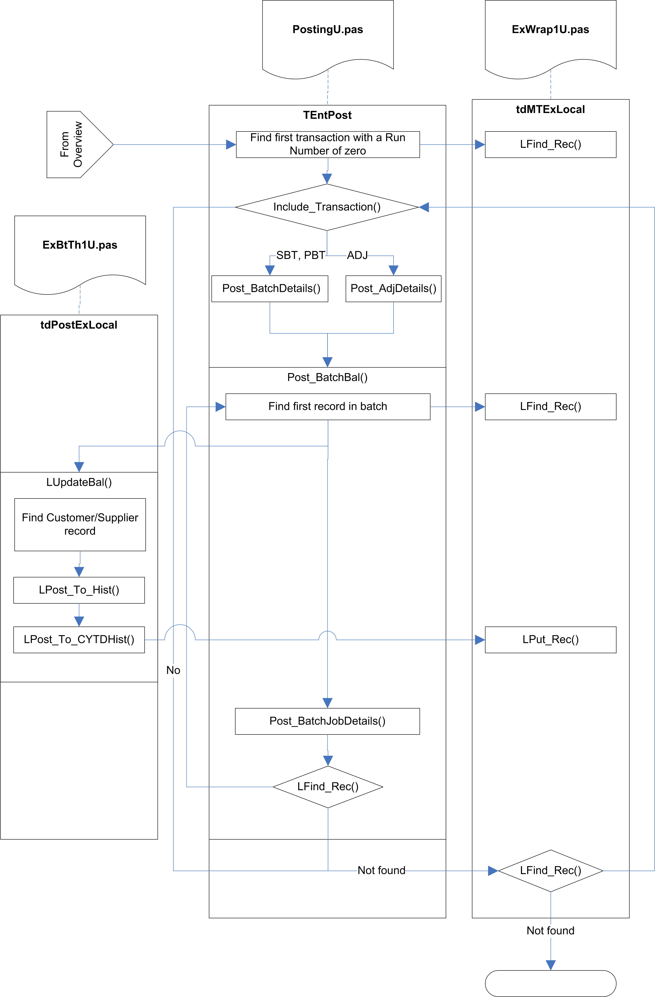

Fig.3 Post_ItBatch

TEntPost.Post_ItBatch (PostingU.pas)

Prepare job-costing
If the JobCostOn (VarConst.pas) global flag is set to True, a PostJobObj object is created. Subsequently, the MTExLocal record structure of TEntPost is copied to the MTExLocal field in the PostJobObj.

Locate first batch record
The routine searches for the first transaction with a run number of zero.

Increment PostingCount
The PostingCount variable keeps track of the number of transactions actually posted, and is eventually used to… ???

Update LastFolio
If the current transaction has a folio number greater than the current LastFolio number, LastFolio is updated with this folio number.

The LastFolio value will be used in the main posting routines to check for and ignore transactions that were added after the posting run was started.

Check transaction
The Include_Transaction routine is called to determine whether the current transaction should be included in the posting run.

Included transactions are:
- Document type SBT, PBT, or ADJ
- Not on hold or suspended
- Not for a future period
- Not for a past period, unless the system flag to allow posting into previous periods is set.
- Not for a future transaction date
- Not in a purged period
- Not before the last audit date

Lock record
The transaction record is locked. If it cannot be locked for any reason, it is simply ignored.

Post details
For document types SBT and PBT, the Post_BatchDetails routine is called. For document type ADJ, the Post_AdjDetails routine is called.

Save record
The current transaction record is locked, and the run number is updated. The record is then saved and unlocked.

Update customer/supplier balance
If the batch has not already been posted, Post_BatchBal is called to update the balances for each transaction in the batch. This in turn calls LUpdateBal to do the actual updating, and calls LUpdate_JobAct for each transaction line of the current transaction, to update Job Actuals.

Next record
The next batch transaction record is located and, if found, we loop back to Increment Posting Count.

TEntPost.Post_BatchDetails (PostingU.pas)

Parameter | From Post_ItBatch
BInv: InvRec | Current transaction record
TTEnabled: Boolean | False
PostOPtr: Pointer | PostJobObj (Job Posting object)

Locate batch transactions
The OurRef of the transaction record is used to find the first transaction for this batch.

Lock record
The record is locked. If this fails, the record is simply ignored.

If TranOk2Run is True, a Btrieve Transaction is started, to allow any changes to be rolled back if something goes wrong.

Determine VAT Date
If the VAT Scheme indicator in the System Setup indicates that VAT on Cash Accounting is in use (that is, if SyssVAT.VATRates.VATScheme holds ‘C’), and if the current document is one of the direct payment types (SRF,SRI,PRF,PPI), then the VAT date is calculated.

Currently, this is simply read from the System Setup (SyssVAT.VATRates.CurrPeriod), but in future it will be calculated using the CalcVATDate function in SysU1.pas – this function calculates and returns the VAT date based on the supplied transaction date. If the transaction date indicates a date in advance of the current period, it returns the last day of the month that the transaction date actually falls in.

The UntilDate is set to today, to indicate that this transaction was fully allocated at this date.

Set document allocation status
The Set_DocAlcStat procedure in CurrencyU.pas is called to the set the allocation status.

If the document is in the Allocation set (PIN,PCR,PJI,PJC,PPY,SIN,SCR,SJI,SJC,SRC), the AllocStat field is set to ‘S’ for supplier or ‘C’ for customer, and #254 is stored in the UntilDate field. For other document types the AllocStat field is set to #0, and the UntilDate field is left unchanged.

If the System Setup authorisation mode holds ‘A’, and the HoldFlg value does not indicate that the record in on hold, the HoldFlg value is set to HoldP – Authorise Payment.

Save record
The record is saved and unlocked.

If a Btrieve Transaction is active, it is either committed or (if the save failed) rolled back.

Update customer/supplier balance
If the System Setting UpBalOnPost is True (indicating that customer/supplier balances should only be updated on a post, rather than being updated straight away), or if a Btrieve Transaction was used, this section is ignored.

The LUpdateBal method is called to do the actual updating.

Update Job Costing
If we are not in a Btrieve Transaction, and Job Costing is active, the Post_BatchJobDetails method is called. This calls LUpdate_JobAct for each transaction line of the current transaction.

Find next record
The next transaction record is located, if any, and the routine loops back to Lock record.

TPostJob.LUpdate_JobAct (JobPostU.pas)

Parameter
Idr: IDetail | Transaction line record
InvR: InvRec | Transaction header record

Locate record
This locates a record which matches the Folio Number and Absolute Line Number of the transaction line. If no record can be found, a new record will be added, otherwise the record is locked.

Check transaction line
The Job Actual record will only be created or updated if the transaction line fulfils the following requirements:

- A Job Code is specified.
- NomAuto is set to True.
- The line number is greater than or equal to zero, or the document type is not one of JCT, JST, JPT, JSA, or JPA.
- The document type is not JPT.
- The document type is not JST, unless DeliverRef is non-empty.
- The document type is not one of JSA, or JPA, unless the line number is zero.
- The document type is not one of SRN, or PRN.

Assign/calculate values
The Job Actual values are copied from the transaction line. Qty, Cost, Charge, and Uplift values are recalculated, based on the document type and on additional information looked up in the JobMisc, Stock, and Customer/Supplier tables.

Save record
The Job Actual record is saved or added, and the lock is released.

TEntPost.Post_AdjDetails (PostingU.pas)

Parameter | From Post_ItBatch
BInv: InvRec | Current transaction record
Var GotHed: Boolean | Not Syss.AutoValStk
Var NInv: InvRec | Empty invoice record
PostOPtr: Pointer | Job Posting object

This routine creates a nominal transfer record, if required, for the current transaction. The new transaction header will be returned in NInv (if a new record was not created, NInv will hold a copy of BInv).

Note: this routine is extremely complex, and the following description skims over most of the details (largely because I do not understand the business rules that are being implemented).

Check Stock Valuation flag
The AutoValStk system setting is checked. If this is True, a Nominal Transfer record is required.

Create Nominal Transfer record
Create_NTHedInv (in RevalU2U.pas) is called to create the actual record, copying the details from BInv, and marking the transaction as external document (to prevent user-editing of it).

Locate transaction lines
The transaction lines against the current transaction are located and processed.

Update history
Stock_PostCtrl is called to add or update the various balance history records based on the current transaction line, using LPost_To_Hist2 and LPost_To_CYTDHist2. For some lines, the Customer / Supplier / CostCentre / Department balance history records are also updated, using Ctrl_CuStkHist.

Substitute stock parameters
The stock location record is found, and if necessary the nominal codes are copied across from the location record to the stock record.

Get nominal codes
The nominal codes are retrieved either from the Stock record or from the BOM parent record (if one exists).

Call hook point
If the Adjustment Nominal Code hook point is enabled, the hook point is called to allow the nominal codes to be changed.

Add stock valuation lines
Stock valuation lines are added via the Add_StockValue routine in RevalU2U.pas.

This searches all transaction lines for a match with the Stock Valuation Code (-21), the Nominal Code (either Closing Stock or BOM GL), and the Cost Centre and Department of the current stock item.

If a match is found, the Net Value is updated.

If no match is found, or if the Separate Control Posting system flag is set to True, a new Nominal Transfer transaction line is created and the values are copied into it.

Add Job Costing uplift
If the current transaction line has a Job Code, and the matching Job Actual record contains an Uplift value, a stock valuation line is added for this as well.

Finalise transaction line
The Folio Number of the transaction is copied to the B2BLink field of the line.

It then searches for the next transaction line and loops back to Update history.

Finalise transaction
If Auto Stock Valuation is active, Reset_NomTxfrLines in RevalU2U.pas is called to set the run number for the transaction lines.

Main Posting

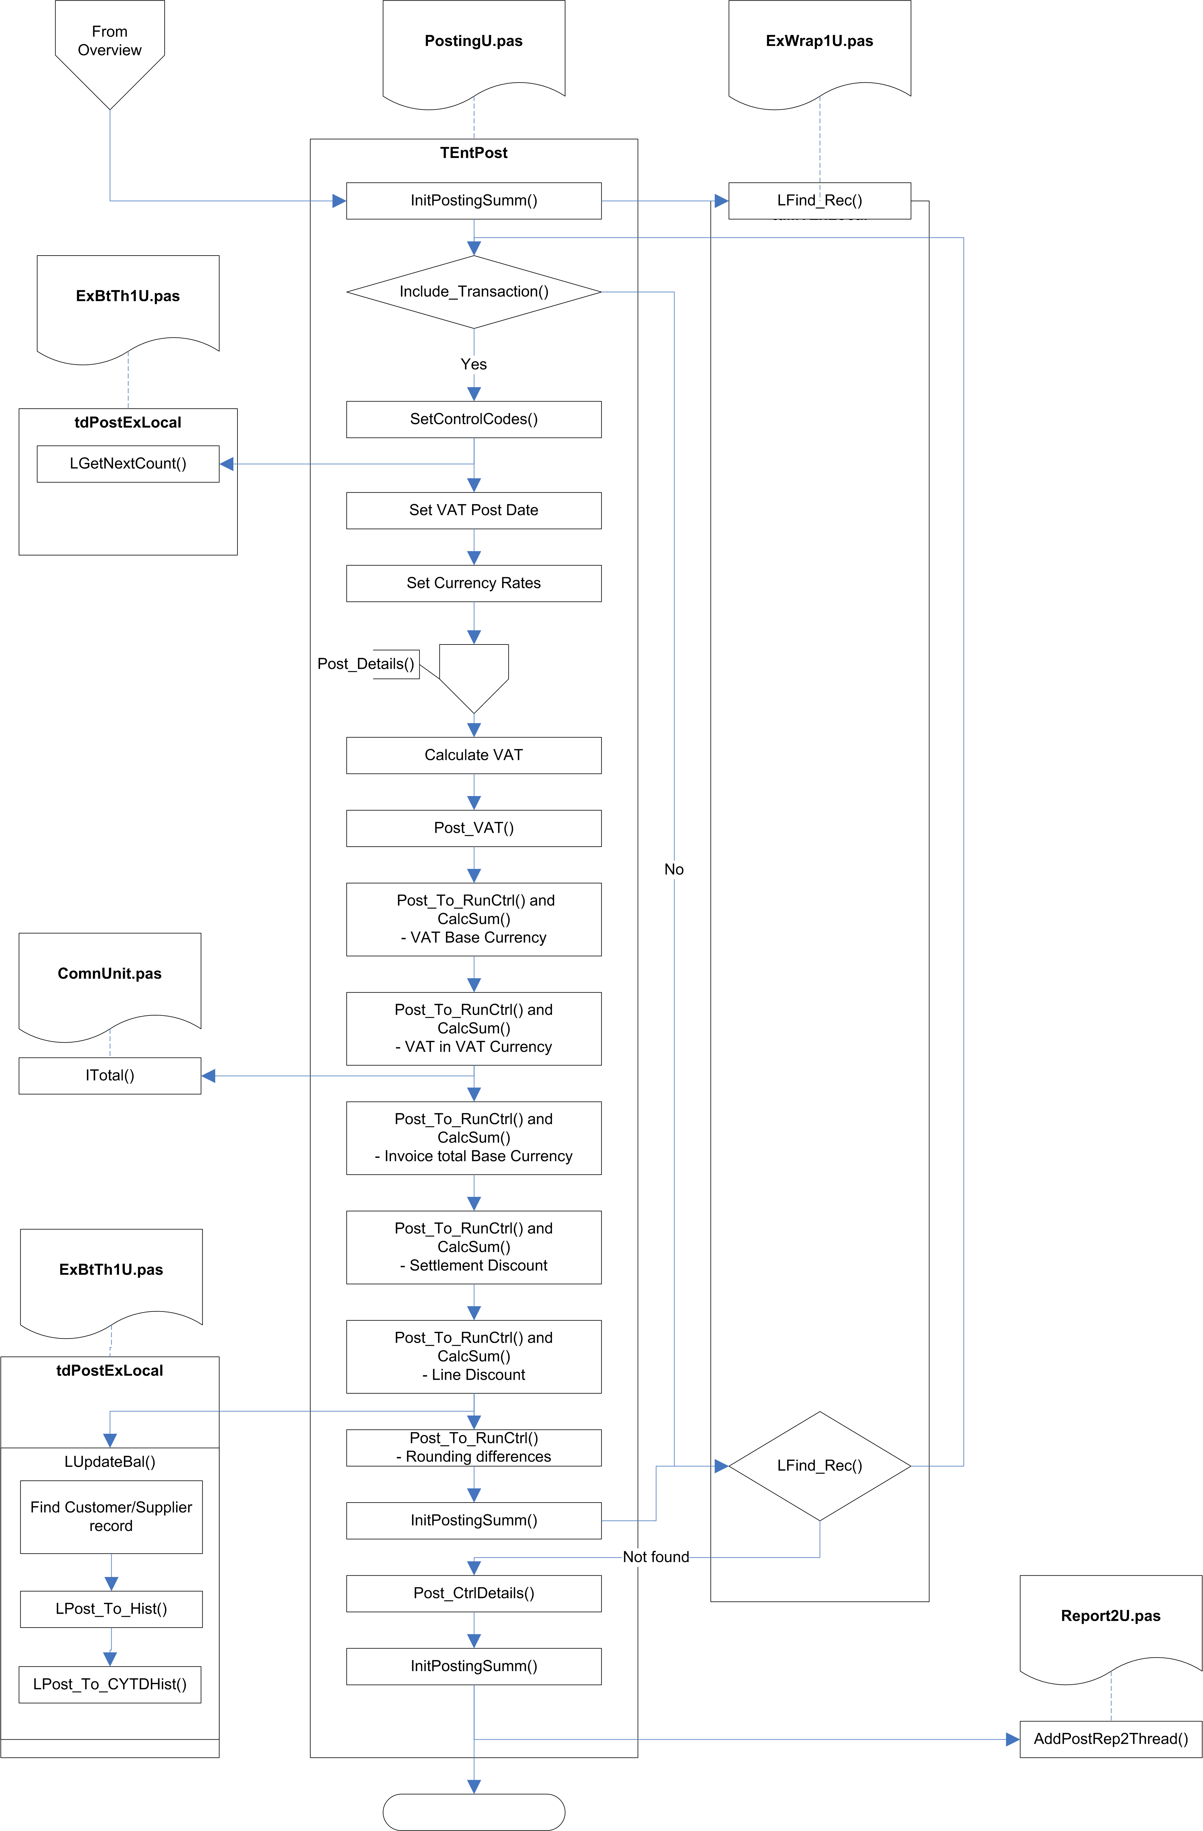

Fig.4 Post_It

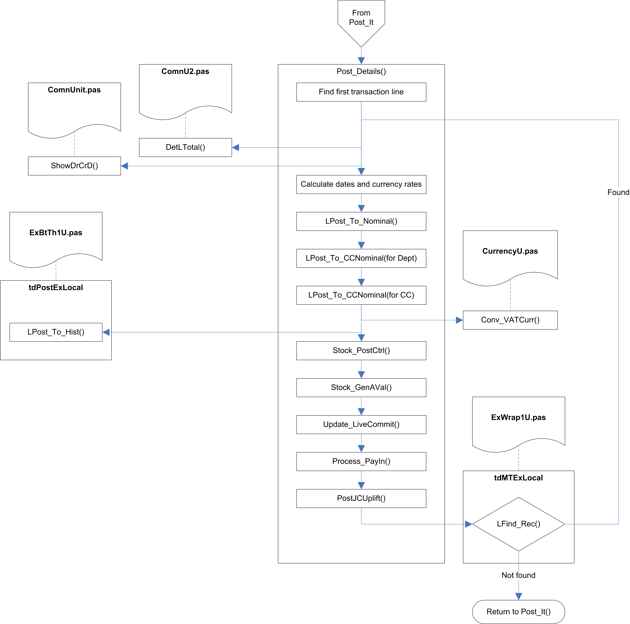

Fig.5 PostDetails

TEntPost.Post_It (PostingU.pas)

Initialise
The thread queue progress is initialised, and the Posting Summary array is initialised (all the values are set to zero).

The first transaction with a run number of zero is located.

Check transaction
The item count and progress are updated.

The Include_Transaction routine is called to determine whether the current transaction should be included in the posting run.

Included transactions are:
- One of the selected document types (as stored in PSet)
- Not on hold or suspended
- Not for a future period
- Not for a past period, unless the system flag to allow posting into previous periods is set.
- Not for a future transaction date
- Not in a purged period
- Not before the last audit date

Prepare transaction for editing
The transaction record is locked, an array of G/L codes relevant to the transaction type is populated, and the next run number is read from the Document Numbers table. The posting date is set to the current date.

If cash accounting is not being used, the VAT Post Date is set.

The currency rates are read from the system defaults.

Post transaction lines
The PostDetails method is called to process all the lines for the current transaction.

Post control code lines
Additional transaction lines are added for:

VAT in Base Currency
VAT in VAT Currency
Invoice Total in Base Currency
Settlement Discount
Line Discount
Rounding Differences

Finalise transaction
The CIS Date is set, the transaction record is stored and unlocked.

If there are more transactions, the next transaction is found, and the system loops back the Check transaction.

Post Nominal Codes
For every nominal code, this locates all the transaction lines from the current run, and calls Post_To_Nominal for each one, which updates the balance history for the G/L code, and for all the parent entries above the G/L Code in the G/L tree.

Print summary report
A report is created from the Posting Summary array, and passed to the thread queue for processing.

TEntPost.Post_Details (PostingU.pas)

Parameter | Notes
DocFno: LongInt | Folio number
RunNo: LongInt | Run number
VYr: Integer
VPr: Integer
CtrlSet: ControlAry | Array of nominal codes
LineTotal: Real | The line total is passed back via this parameter.
AutoRecover: Boolean

Locate first transaction line
The supplied Folio Number is used to locate the transaction lines for the current transaction.

Calculate totals
The DetLTotal function (in ComnU2.pas) is called to calculate the total for the line, then the other values are calculated – Debit/Credit, Cleared, etc. – along with the Year and Period and the conversion rates.

The line total net value is calculated.

Update balance history
The various combinations of Cost Centre and Department balance histories are updated, using the LPost_To_Hist and LPost_To_CCYTDHist functions (see above).

The transaction line is saved.

The VAT history is calculated and stored using LPost_To_Hist.

Stock_PostCtrl is called to add or update the various balance history records based on the current transaction line, using LPost_To_Hist2 and LPost_To_CYTDHist2. For some lines, the Customer / Supplier / CostCentre / Department balance history records are also updated, using Ctrl_CuStkHist.

If Stock Auto Valuation is active, additional lines are created for Cost Of Sales control codes. A hook point is called for each line, to allow plug-ins to change the assigned Cost of Sales control code.

Process pay-in lines
If the UsePayin system-settings flag is True, pay-in transaction lines are generated.

Process job costing
If Job Costing is active, the current line is checked to see if Uplift is required, and if so, additional transaction lines are created as control lines.

Finalise transaction line
The transaction line is unlocked, and the next transaction line is located. Assuming more lines are found, the system loops back to Calculate totals.

Code sample

From PostingU.pas

If (LStatusOk) and
((Not (LInv.InvDocHed In RecieptSet+NomSplit))
or ((LInv.InvDocHed In NOMSplit) and (LInv.NomVATIO<>C0)))
and (VATCode<>C0)
and (LineNo<>StkLineNo)
and (Not (LInv.SSDProcess In ['P','T']))
and (Not VAT_CashAcc(SyssVAT.VATRates.VATScheme)) then
Begin

{ ========= Post to VAT History for Line ========== }

If (Not (LInv.InvDocHed In NOMSplit)) then
Begin
If (LInv.OldORates[UsecoDayRate]<>0.0) then
{* We have been through a conversion, and this needs to be stated
in original currency *}
LineVATRate:=LInv.OldORates[UseCoDayRate]
else
If (UseCoDayRate) then
LineVATRate:=LId.CXrate[UseCoDayRate]
else
LineVATRate:=LInv.OrigRates[UseCoDayRate];
end
else
LineVATRate:=LId.CXrate[UseCoDayRate];

Cleared:=Conv_VATCurr(DetLTotal(LId,BOn,LInv.DiscTaken,LInv.DiscSetl),
LInv.VATCRate[UseCoDayRate],
LineVATRate,
LInv.Currency,
LInv.UseORate)*DocNotCnst;

If (Cleared<>0) then
LPost_To_Hist(IOVATCode(IdDocHed,LInv.NOMVATIO),
FullCustCode(SyssVAT.VATRates.VAT[GetVATNo(VATCode,VATIncFlg)].Code),
0,Cleared,0,0,VYr,VPr,
Cleared);
LStatus:=0;
end;

